PARS AI Agent
Multi-Agent Architecture for Autonomous Medical Coding & Compliance

1. System Overview
This system is an enterprise-grade multi-agent AI architecture designed to automatically process clinical encounter notes, retrieve relevant ICD-10/CPT codes using semantic retrieval, apply clinical reasoning to assign codes, enforce payer-policy compliance, and log decisions for auditability and operational metrics.
2. High-Level Architecture
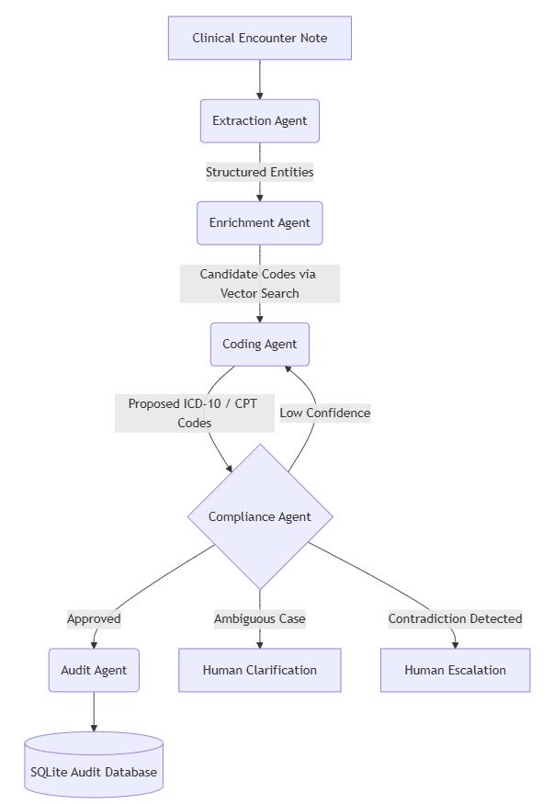
The pipeline ensures that coding decisions pass through compliance guardrails before final approval, minimizing billing errors and ensuring payer-policy adherence.

3. Agent Roles
Extraction Agent
Purpose
Convert unstructured clinical notes into structured medical entities.
Model
llama-3.1-8b-instant
This lightweight model is used for fast, cost-efficient NLP extraction tasks.

Enrichment Agent
Purpose
Retrieve possible medical codes related to extracted entities using vector search.
Tools
- ChromaDB
- Sentence-transformers embeddings (all-MiniLM-L6-v2)

Coding Agent
Purpose
Apply deep clinical reasoning to determine appropriate codes.
Model
llama-3.3-70b-versatile
This model is used only for complex clinical reasoning tasks.

Compliance Agent
Purpose
Ensure coding decisions follow payer policies and regulatory rules.
Possible Outcomes
- Approved
- Reflection required
- Clarification required
- Escalation required

Audit Agent
Purpose
Provide system traceability and operational metrics.
Storage
SQLite Database

4. Agent Communication Model
Agents communicate through a shared LangGraph state object.
Example Interaction Flow
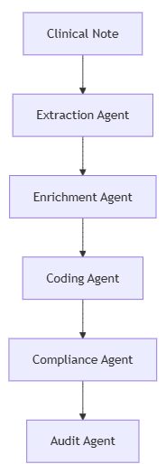
5. Error Handling and Guardrails
The architecture includes several robust safety mechanisms.

Self-Reflection Loop
If the Compliance Agent detects a policy violation or hallucinated code, it triggers a reflection loop.
Compliance → needs_reflection = True
The pipeline automatically routes back to the Coding Agent with feedback.
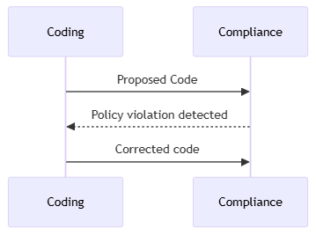

Escalation Logic
Certain scenarios require manual review.
Examples include:
- Contradictory clinical information
- Missing documentation
- Confidence score below threshold
Graceful Degradation
If LLM services become unavailable, the system falls back to vector retrieval.
Fallback pipeline:
Extraction → Vector Retrieval → Best Matching Code
This ensures continuous operation in clinical environments.
6. Observability and Metrics
All decisions are logged in the audit database.
Tracked metrics include:
- Autonomous coding success rate
- Escalation frequency
- Average confidence score
- Throughput performance
Example savings calculation:
Savings = Autonomous Cases × $35 manual coding cost
These metrics power the React performance dashboard used for operational insights.

Summary
The Healthcare Operations AI Agent architecture combines:
- Multi-agent AI orchestration
- Retrieval-Augmented Generation
- Compliance rule engines
- Human-in-the-loop escalation
- Full audit traceability
This modular design enables scalable, compliant, and autonomous clinical coding workflows while maintaining strict operational safeguards.

